Librera Search v1.x
Librera Search v1.x solution built with Angular 16, Hangfire Server and .Net 8

Contents
Requirements 2
Overview 3
Scope 4
RQ-01 | Automated Task Service 5
RQ-02 | Indexer 8
RQ-03 | Model Layer 9
RQ-04 | Web API 10
RQ-05 | Front end App 12
RQ-06 | Database 16
Deployment 17
Software life cycle management 18
Annexes 19

Doc. Version | Date | Author | Description
1.0 | 2025-12-05 | Name and surname | 1.x version of the release

Requirements
The next table shows the requirements for the solution described.
Requirement | Description
RQ-001 | Automated Task Service | Hangfire offers the possibility to manage automated task services to process PDFs
RQ-002 | Indexer | The indexer libraries that contains the logic to process the PDFs
RQ-003 | Model Layer | The model layer with EF core to interact with database
RQ-004 | Web API | The back-end to execute CRUD operations in server
RQ-005 | Front end App | Angular App to offer UI to manage the records and associated records
RQ-006 | Database | The data model, full text search and index services and the logic needed by Stored Procedures

Overview
This document contains the technical details of the Librera Search v1.x solution built with Angular 16, Hangfire Server and .Net 8; enables to index content from PDFs making it searchable with the possibility to classify them by the Web UI. Implements token-based authentication for registered users and policy-based authorization in the endpoints.
The application contains the next functionality:
- Each register has id, title ,authors ,series, ids, published, publisher, languages, tags, formats, path and indexed content
- We can create, retrieve, update, delete records, launch the index service and search PDF content linked to the records
- Includes two pages for finding registers by title or search indexed content
- JWT (JSON Web Token) format used for authentication
- Policy-based authorization in the endpoints
Here the solution structure in Visual Studio 2022:
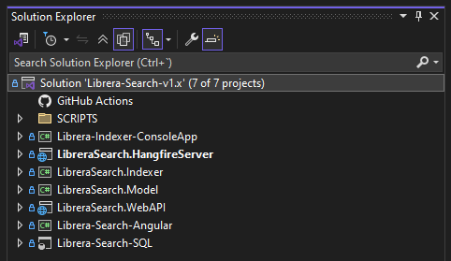

Scope
This first version of the solutions grants a view of how could be easily implemented in .NET 8 a simple but effective tool to manage book records and make content searchable using open source elements like Hangfire and front-end technologies like Angular.

RQ-01 | Automated Task Service
An easy way to perform background processing in .NET and .NET Core applications. No Windows Service or separate process required. Backed by persistent storage. Open and free for commercial use.
Here the Book Indexer Job definition in the dashboard:
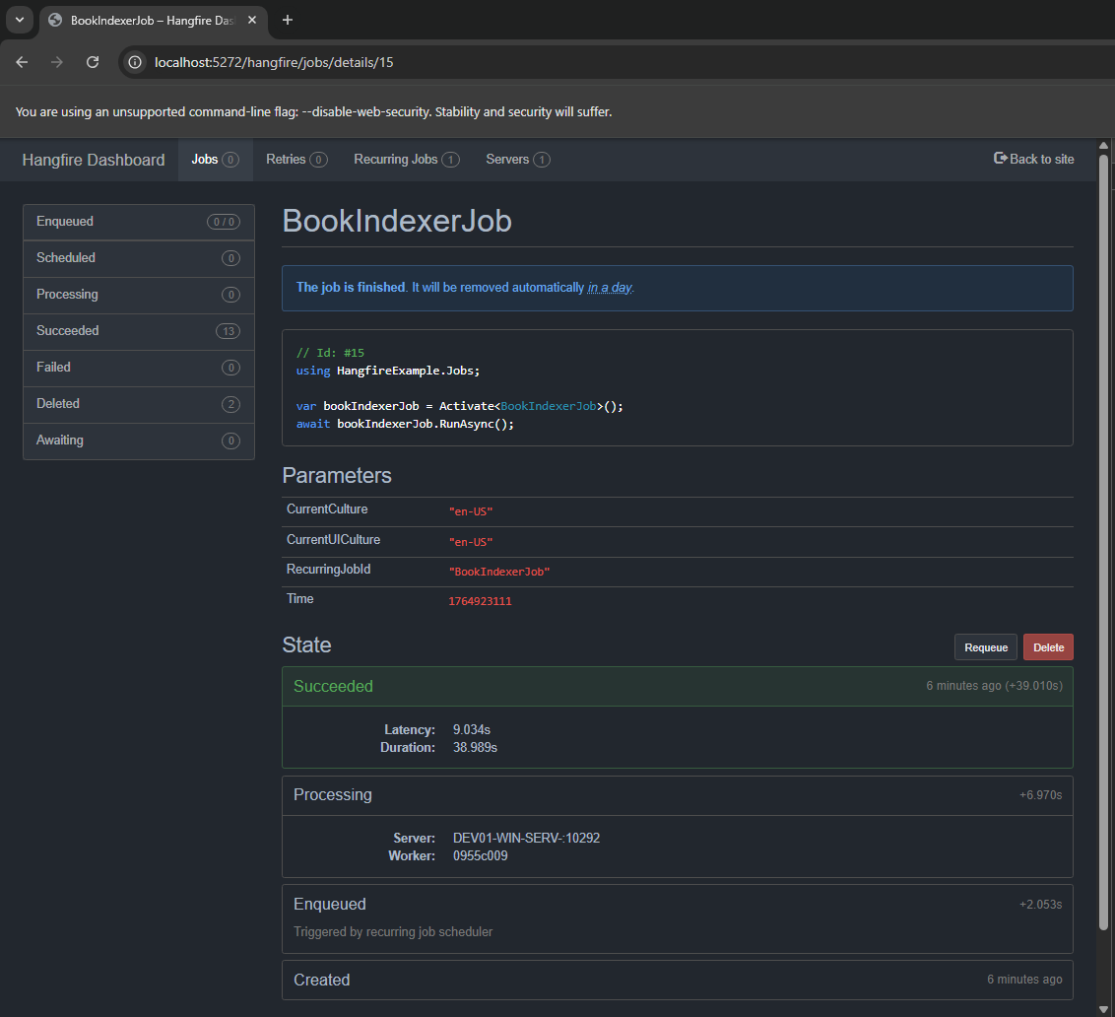
The next image image shows the process graph:
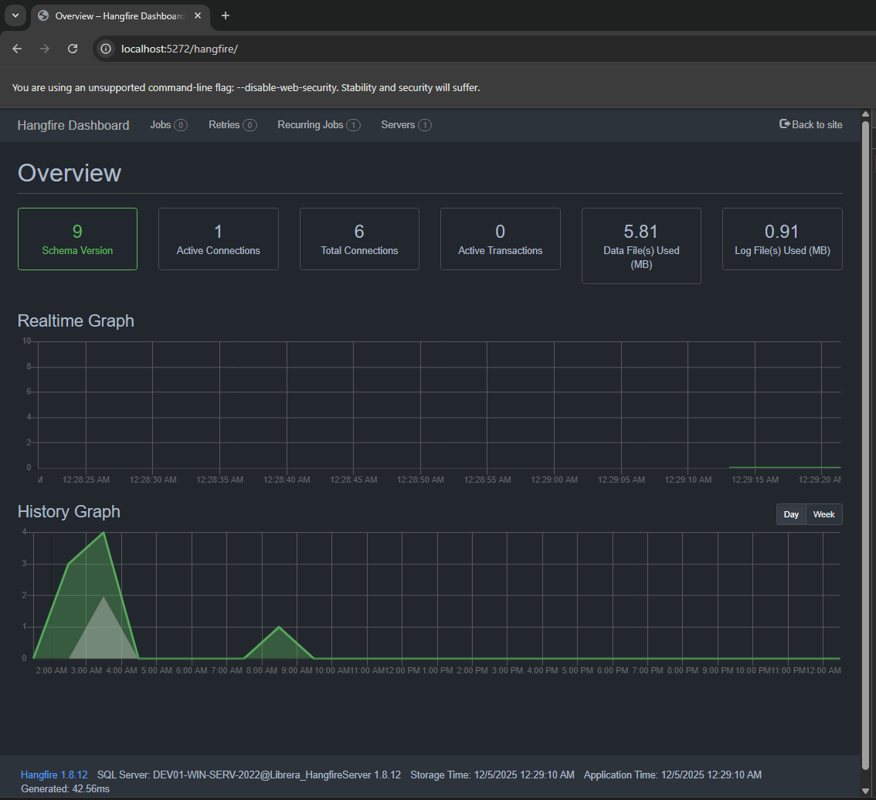
Here the recurring Job:

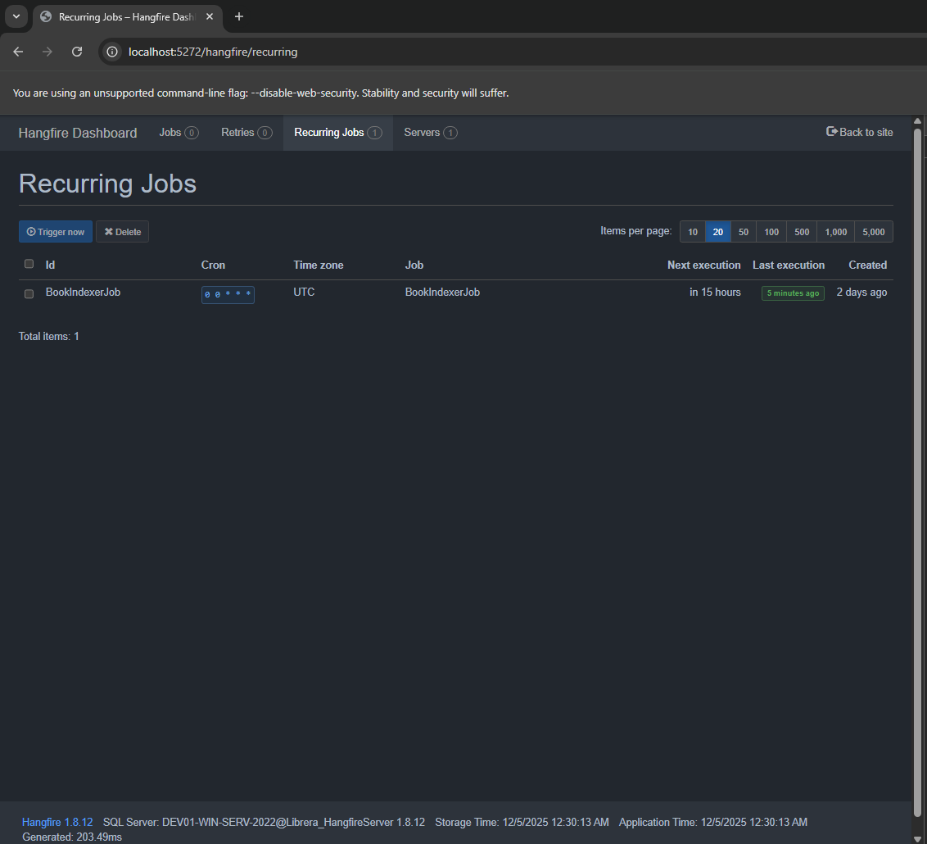
Here the Hangfire service definition for the Job:
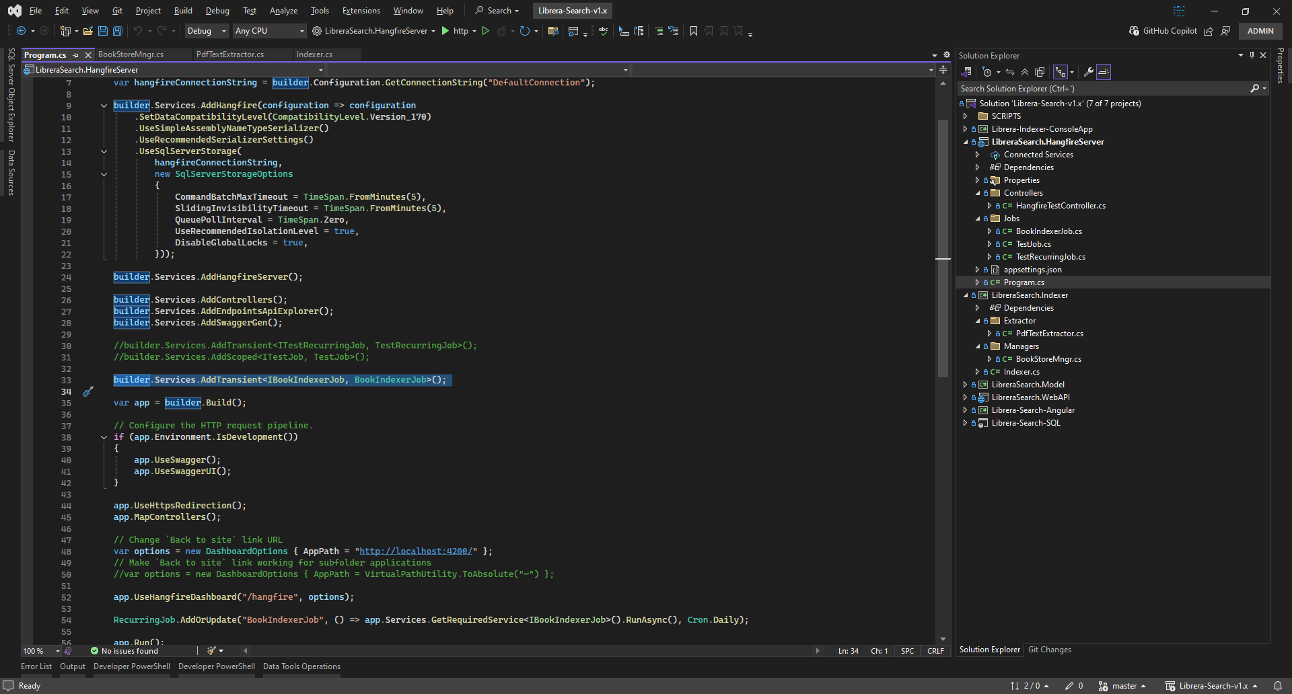

RQ-02 | Indexer
The indexer is implemented by a library type project on which we have the PDF extractor and the c# method that the Hangfire service will call by a recurring job definition.
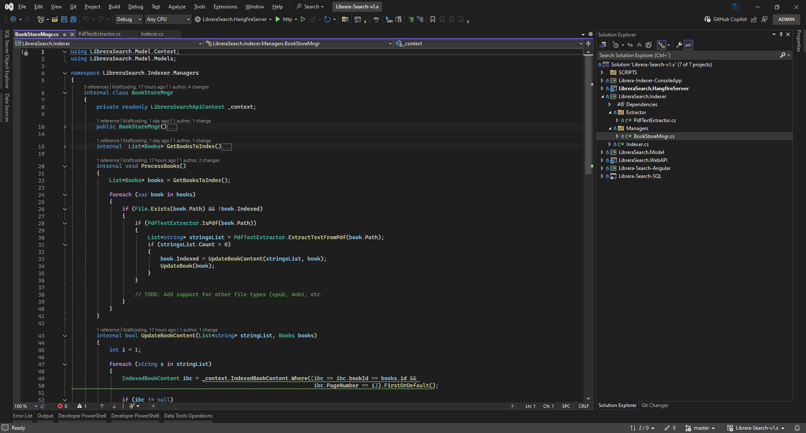
The indexer extraccts content form PDFs and stores it in DB.

RQ-03 | Model Layer
The model layer is managed by EF Core and LinQ is used to launch the queries.

RQ-04 | Web API
The Web API permits to the front-end application to execute CRUD operations my RESTful end-points. Those end-points are securitized by policy-based authorization.
Here some images.
Web API Auth. service setup:
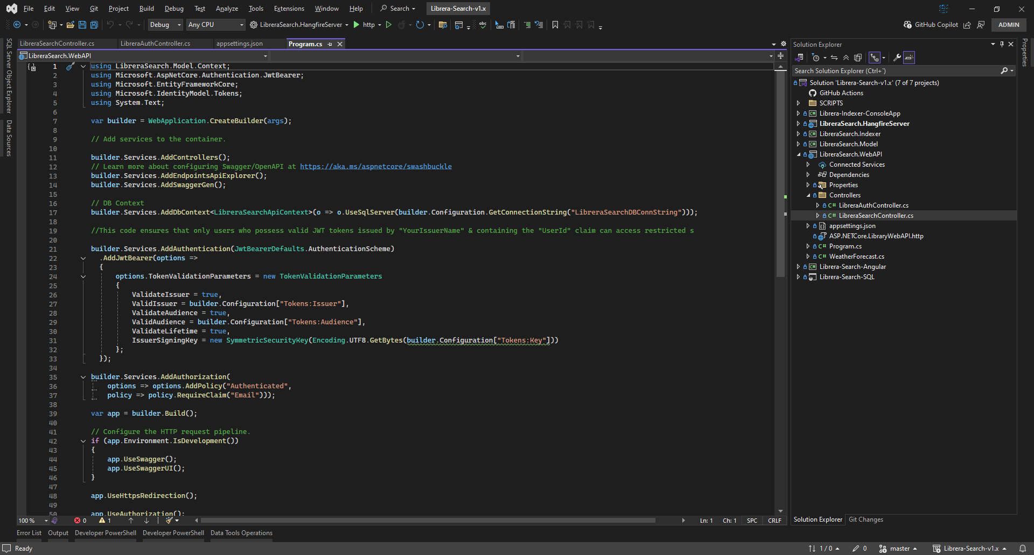
Web API Tokens configuration:
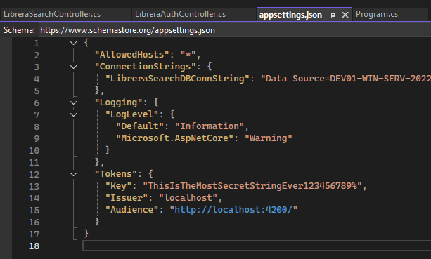
Web API securitized end-points:
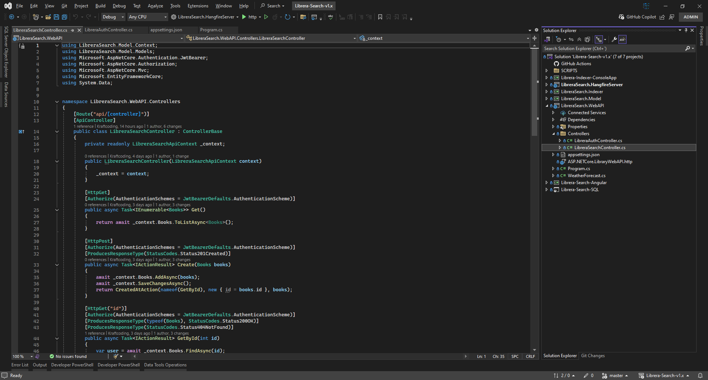

RQ-05 | Front end App
The front end app is built in Angular 16.
Here some images.
Login form:
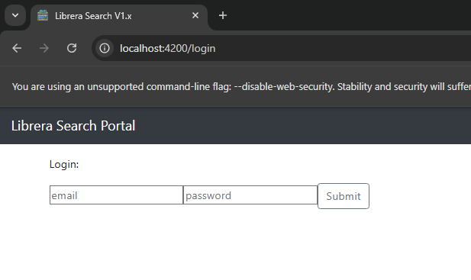
Search by title list and details:
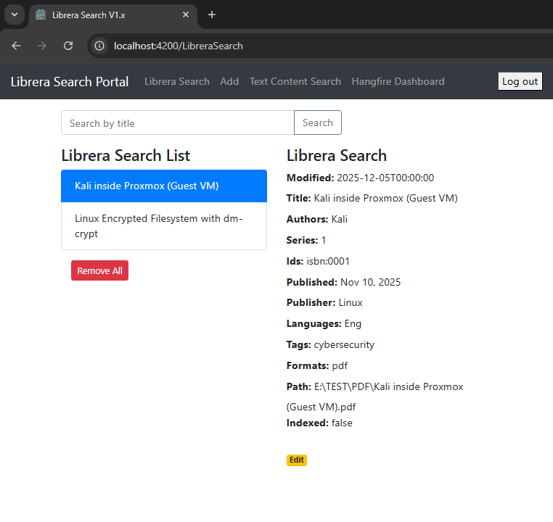
Add form:
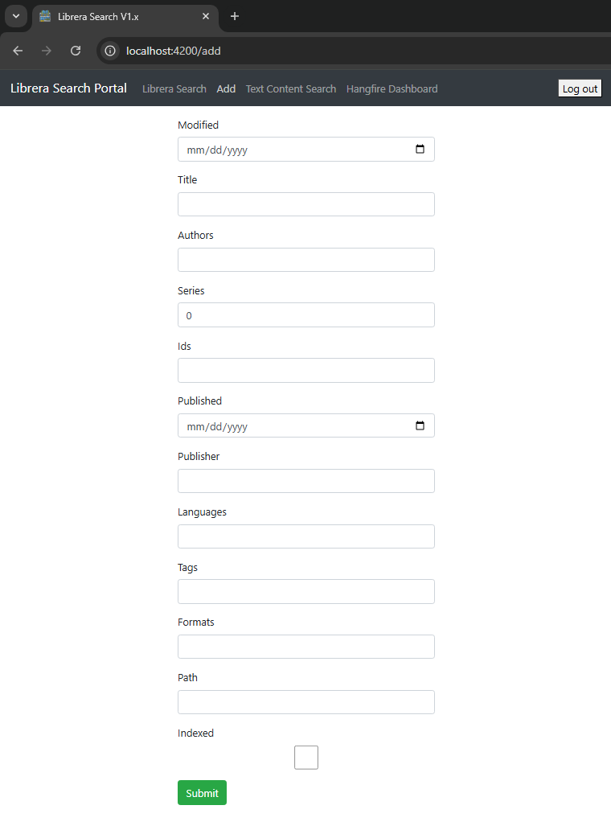
Search by content page details:
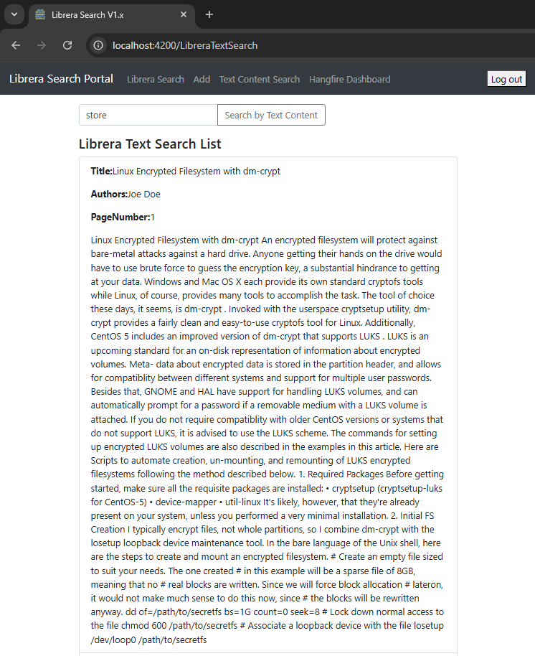

RQ-06 | Database
The database is hosted by M. SQL Server 2022, all the schemas and T-SQL logic is in the project. Full-Text Search feature is needed, as we se in the next image:
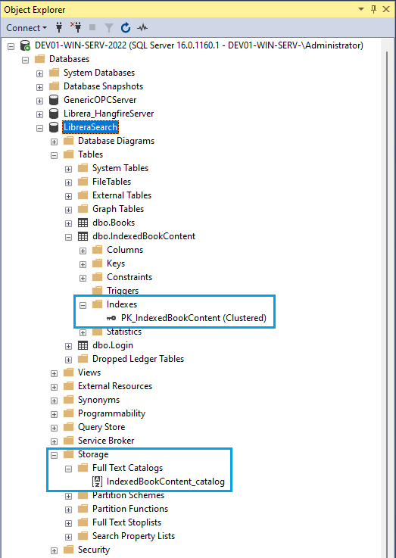

Deployment
To do.

Software life cycle management
To do.

Annexes
A console App is added to test the indexer.
A script is added to launch Chrome avoiding CORS

